RFP #2019-01
Ryan White HIV/AIDS Treatment Extension Act Part A Program and Minority AIDS Initiative Direct Services Pre-Bid Meeting
December 3, 2019

Notations:
- On page 37, Letter G - Performance bond requirement is not applicable for this project.

- Financial Statements and Annual Reports can be very lengthy, for those two required documents you may submit an electronic copy only or one printed copy. Please make sure to reference in each of the additional proposal packets that the documents are included in the original and/or electronic copy.

Questions from attendees:

- What qualifies as an electronic copy?
- An electronic copy of the application is to be provided with the application package, in a CD or flash drive format.

- Has average agency award size increased in recent years?
- Agency awards are dependent on agency processes, needs, and requests.

- Are the attachments fillable forms?
- Attachments are available as Word documents and Excel documents, not fillable PDF format.

- Could you provide more information about CAREWare and its role in the Part A Program?
- CAREWare is a client-level data reporting system where services are entered to show levels of effort as well as a collection tool for program outcomes. There is a monthly requirement to input data into CAREWare in order for invoices to be processed. Agencies should be mindful when requesting funds as this data entry is an allowable cost that can be budgeted for and requested. CAREWare, ultimately, is the reporting tool used to report services to the federal government annually.

- Is CAREWare free?
- CAREWare is a free system, and agencies will be given access upon award.
- Our organization uses multiple fringe benefit rates, how should we go about filling out the budget template?
- A: Question #2 on the tab labeled “COMPLETE FIRST” will ask you if your organization will be using a fringe benefit rate. Answer yes to this question and input your rate in the box that appears. If you have multiple rates you do not need to put those rates in that box. In ‘Column G’ of the Fringe Cost section on the subsequent tabs for each of the service categories, you will input the fringe benefit rate associated for each staff member. If you are awarded the grant we will ask for proof and backup of these rates from the provider agency.

- Where can we find all the sample documents to download?
- A: All of the documents can be found under the heading “Active 2019 Requests for Proposals (RFP)” at this link https://www.ccbh.net/rfqs/.

- Could you describe the budget negotiation process?
- Awarded agencies will come to CCBH for a budget negotiation meeting to discuss what funds can be allocated per service category based on Planning Council allocation percentages and requests across TGA. This meeting takes between 2-3 hours, and a formal contract can be processed after the meeting is completed. At this meeting, Part A staff and awarded agencies also go over grant expectations, invoicing, etc.

- What is the turnaround time from budget negotiation to a formal contract being processed?
- This is dependent on awarded agencies internal processes. The quicker the budget is processed by the agency and approved by Part A, the quicker the funds can be processed.

- Referencing Page 5 Category C (Targeted Sub-populations) of the grant application, in terms of requesting agencies to target those subpopulations, what are you looking for?
- Part A requests that agencies explain how they will address these target sub-populations as they are disproportionately impacted by HIV/AIDS; and how they will get those clients linked to care, retained in care, on medication, and virally suppressed.

- Is there a list of allowable costs?
- There is a list of unallowable costs found within the RFP (starting on Page 16 Section H. Funding Exclusions and Restrictions). If you are unsure if a cost is allowable or not, a discussion for clarification can be had at the budget negotiation meeting.

- What priorities have PC identified?
- Below are the priority rankings that Planning Council decided for the upcoming grant year:
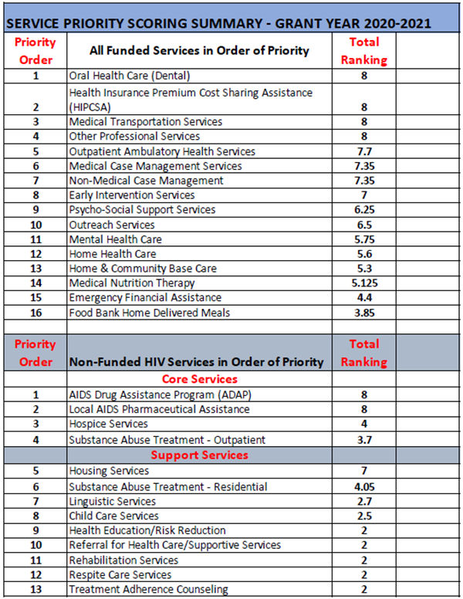

- Can you explain what time commitments are required as a funded agency?
- We have an annual “kick off meeting” that all Part A funded staff are required to attend. We also hold trainings throughout the year that are specific and required for certain staff (I.E. social workers, housing case managers, etc.). Funded

agencies are also required to participate in the Clinical Quality Management Committee, which requires participation in QI projects, activities, and meetings throughout the year. Planning Council is an optional component for funded agencies to attend.

- When can applications be delivered?
- Applications can be delivered to CCBH during business hours (8:30am – 4:30pm) Monday through Friday. Agencies who deliver their application in-hand will get a signed receipt of submission from CCBH.

- When would an agency expect a Notice of Award?
- Agencies should expect to receive notification by February 2020 as to if they are an awarded agency. However, funding is dependent on the federal government releasing funds to the Part A jurisdiction. This will not occur until after the grant year has started (March 2020) but there is no official timeline.

- When it comes to Medicaid, is a patient eligible for Medical Case Management if they are receiving Medicaid?
- Yes. A Medical Case Manager can provide intensive medical case management based on the Standards of Care listed on the Ryan White Part A website.

- Does a Medical Case Manager need a social work degree?
- Yes, please refer to the Standards of Care for details. Please refer to Standards of Care and be aware of what is required and become familiar with the service prior to bidding on the service. The standards are developed with the help of the community and updated annually.

- Is there guidance on how many units in CAREWare equate to a ‘% of FTE’ for purposes of requesting adequate funding?
- There is no formal guidance on the amount of units that are entered into CAREWare, which is done purposefully to allow for new agencies startup. At a minimum, it is expected that at least 50% of a FTE’s time be documented in units in CAREWare.

- For those requesting new service categories with intention of starting new programs at their agencies, should we explain our plans for the future, or focus on the first year of award?
- New service category requests should focus on the first year of service. Tell how the agency plans on delivering services, what unique characteristics are tied to it, and what goal will be accomplished with the addition of that service category.

- When awarding funding, is there any preference given for agencies that serve populations in high incidence zip codes?
- It is encouraged that the prospective agency explains in their RFP response who they will serve and how they will serve them. Explain the populations that you serve in detail and your goals of getting those clients engaged in care.

