Clinical Quality Management Committee Meeting
Cleveland TGA
February 13, 2017 Meeting Minutes

Attendees:

Name | Agency/Affiliation | Representing
Erica Shields | AIDS Healthcare Foundation | Part A Funded Agency
Bob Candage | AIDS Taskforce | Part A Funded Agency
Sherrell Lipscomb | Cleveland Clinic | Part A Funded Agency
Sandrell Porter | DSAS | Part A Funded Agency
Doug Vest | May Dugan | Part A Funded Agency
Summer Barnett | Mercy Medical | Part A Funded Agency
Dr. Ann Avery | MetroHealth | Part A Funded Agency
Kim Rodas | Neuva Luz | Part A Funded Agency
Myrtle Watson | Orca House | Part A Funded Agency
Kristin Ziegler Alban | Signature Health | Part A Funded Agency
Michelle Kucia | University Hospitals | Ryan White Parts A, C, and D
Jane Russell | Ohio State | Ryan White Part F
Kimberlin Dennis | Community Member | Planning Council - Consumer Representative
Jason McMinn | MetroHealth | Planning Council - QI Representative
Robert Watkins | Community Member | Planning Council - Consumer Representative
Jan Briggs | Cleveland VA Medical Center | Community Agency
Mary Beth Gramuglia | Cleveland Clinic | Community Member
Ashley Hollohazy | Mercy Medical | Community Member
Melissa Rodrigo | Cuyahoga County Board of Health | Ryan White Part A Office
Kate Burnett-Bruckman | Cuyahoga County Board of Health | Ryan White Part A Office
Zach Levar | Cuyahoga County Board of Health | Ryan White Part A Office
Pam Ditlevson | Cuyahoga County Board of Health | Ryan White Part A Office
Clemens Steinbock | The National Quality Center (NQC) | AIDS Institute, New York State Department of Health

Meeting Minutes:

2:00 - Welcome, Introductions and Opening Remarks - Melissa Rodrigo

2:15 - Disparities overview and agency presentations - Kate Burnett-Bruckman
- Kate reviewed the NQC disparities project goals and objectives and the work that has been done to date by the CQMC.
- Combined disparities calculator was presented - data extracted through CAREWare custom performance measures reports and combined to create an unduplicated look at the TGA specific to Part A. Data showed that if looking at combined Part A data only, the largest disparity is demonstrated among youth aged 13-24. After a brief discussion, Kate was asked to pull reports for the next meeting breaking down that age group into two groups, 13-19 and 20-24. The group agreed that the true discrepancy may be among the older individuals in that group so we will review the data together at the next meeting.

Combined Cleveland TGA Data - 2016
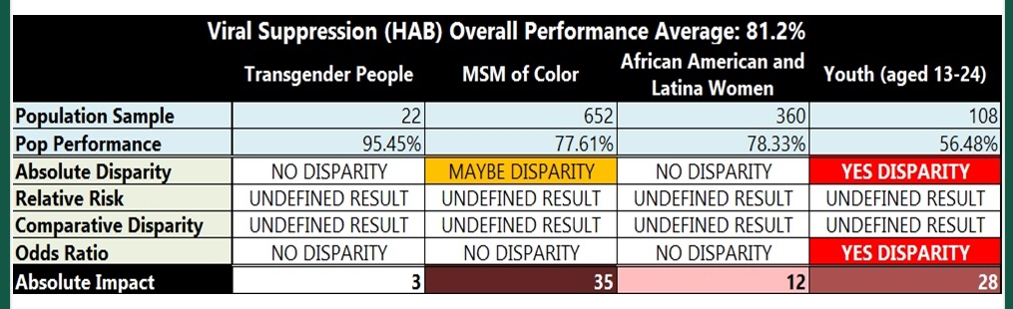

- One slide was then presented for each of the funded Part A agencies outlining their specific data, their identified disparities group, and initial strategies to address the noted disparities. With 12 agencies represented in total, the data showed the following disparities:
  - 1 noted transgender disparity
  - 5 noted MSM of color disparity
  - 2 noted AA and Latina women disparity
  - 4 noted youth disparity

2:45 - AIM Statement Overview - Clemens M. Steinböck, NQC
- Clemens provided a brief overview of what an AIM statement is and a sample form was distributed. Each CQMC member was asked to work on creating an AIM statement specific to Viral Load suppression.

3:15 - HIV Disparities Intervention Update - Clemens M. Steinböck, NQC
- Clemens reviewed the NQC End+Disparities Intervention Grid and supplemental reference sheet with the group. Everyone was asked to look over the grid and specifically look at interventions that focused on VLS and the Disparities group that they had identified.
- Agencies and CQMC Members were then placed into groups based on their areas of interest and/or their identified disparities group. The groups worked together to brain storm AIM statements and intervention ideas. NQC and CCBH staff worked with each group individually as well to assist with any problem solving.
  - Group 1: AHF, CCF and Community Member - Focused on MSM Disparity
  - Group 2: DSAS, May Dugan, Orca House - Focus on MSM Disparity
  - Group 3: ATF and Signature Health - Focus on AA and Latina Women Disparity
  - Group 4: MetroHealth, Mercy Medical, Nueva Luz, University Hospitals, and Community Members - Focus on Youth 13-24

4:00 - Group Discussion - What intervention would work best for us? Clemens M. Steinböck
- Went around the group to talk about what interventions or ideas they have to take home and start researching / implement. Responses included:
  - Research apps to remind clients of appointments
  - Educate clients about the benefit of being virally suppressed
  - Call/text patients to remind them of appointments
  - Start a daily dialog with pharmacist
  - Perform an assessment of successful clients on what keeps them virally suppressed
  - Ensure there is a safe place for clients to come share and be comfortable
  - Medication reviews - working with clients in home to assure medication adherence
  - Follow app usage and concentrate of improving appointment follow through
  - Focus on adherence education
- Each member was asked to submit a completed AIM statement by the end of the day on Friday, February 17th. Completed AIM statements should be submitted to Kate Burnett-Bruckman at kburnett@ccbh.net

4:20 - Next Steps and Wrap Up - Kate Burnett-Bruckman
- Kate to send out an electronic version of the AIM statement form to the group.
- All members should complete an AIM statement and submit it to Kate Burnett-Bruckman at kburnett@ccbh.net by Friday, February 17, 2017.
- Next steps will be to implement the newly created QI VLS plans at each agency and begin to report on progress at the next CQMC meeting.
- Anyone needing direct one-on-one TA regarding their QI project, AIM statement, data, or VLS should contact Kate Burnett-Bruckman via e-mail.
- The next CQMC meeting will be held in the afternoon on Monday, May 15, 2017.

