Clinical Quality Management Committee Meeting
Cleveland TGA
October 24, 2016 Meeting Minutes

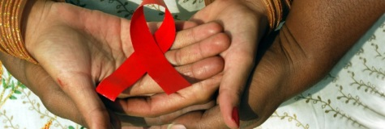

Attendees:

Name | Agency/Affiliation | Representing
Erica Shields | AIDS Healthcare Foundation | Part A Funded Agency
Bob Candage | AIDS Taskforce | Part A Funded Agency
Sherrell Lipscomb | Cleveland Clinic | Part A Funded Agency
Sandrell Porter | DSAS | Part A Funded Agency
Sharon Johnson | DSAS | Part A Funded Agency
Kelly Dylag | Far West | Part A Funded Agency
Doug Vest | May Dugan | Part A Funded Agency
Dr. Ann Avery | MetroHealth | Part A Funded Agency
Ayme McCain | Recovery Resources | Part A Funded Agency
Kristin Ziegler Alban | Signature Health | Part A Funded Agency
Dr. Barb Gripshover | University Hospitals | Part A Funded Agency
Michelle Kucia | University Hospitals | Ryan White Part C and D
Jane Russell | Ohio State | Ryan White Part F
Fatima Warren | The Free Clinic | Community Agency
Tammie Jones | The Free Clinic | Community Agency
Kimberlin Dennis | The Free Clinic | Consumer Representative
Julie Patterson | Silver Creek Strategies | Community Member
Melissa Rodrigo | Cuyahoga County Board of Health | Ryan White Part A Office
Kate Burnett-Bruckman | Cuyahoga County Board of Health | Ryan White Part A Office
Melissa Kolenz | Cuyahoga County Board of Health | Ryan White Part A Office
Clemens Steinbock | The National Quality Center (NQC) | AIDS Institute, New York State Department of Health

Meeting Minutes:

2:00 - Welcome, Introductions and Opening Remarks - Melissa Rodrigo, Cleveland TGA
- All attendees participated in a brief icebreaker activity.
- Kate reviewed survey outcomes from the last CQMC meeting and resources included in the binder to address the two noted items of interest: PDSA cycle explanation and copies of the HRSA/HAB Core Performance Measures.

2:15 - HRSA/HAB Clinical Quality Expectations Overview - Kate Burnett-Bruckman, Cleveland
TGA
- Kate reviewed the background of Title XXVI of the Public Health Service Act requiring all RWHAP to establish CQM programs as well as the tie in to the National HIV AIDS Strategy.
- She reviewed the three needed components of any CQM program (Infrastructure, Performance Measurement, and Quality Improvement) and then talked about what PCN #15-02 means to the members of the Cleveland CQMC.

2:25 - Regional Treatment Cascades and Viral Load Data - Kate Burnett-Bruckman, Cleveland
TGA
- Kate Burnett-Bruckman presented the following updated Cleveland TGA Treatment Cascade:

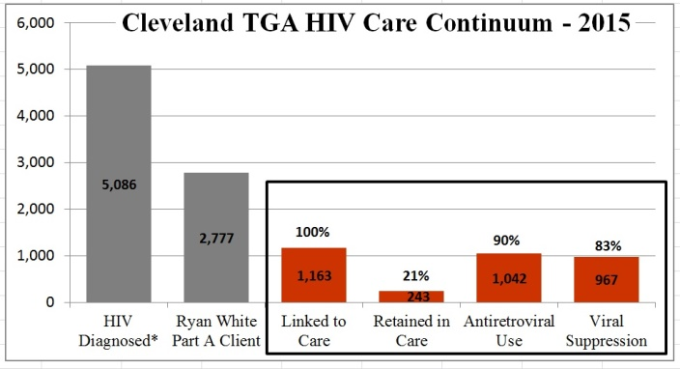

- Kate also presented the following two population continuums:
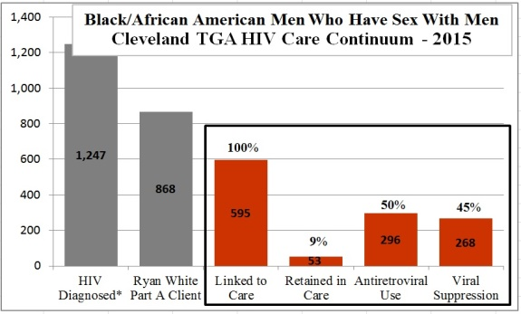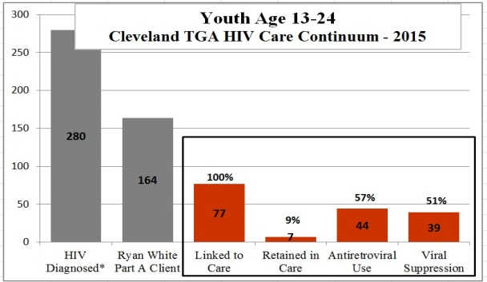

- Dr. Barb Gripshover presented the HIV Care Continuum for University Hospitals of Cleveland to include several breakdowns according to race/ethnicity, gender, and age.
- Dr. Ann Avery presented the HIV Care Continuum for MetroHealth Medical Center to include breakouts according to race/ethnicity, gender, and age.

3:00 - HIV Disparities Literature Review - Clemens M. Steinböck, The National Quality Center
(NQC)
- Clemens played the End+Disparities video for the group. The video can be viewed at: http://enddisparitiesexchange.org/
- Committee members participated in an HIV disparities quiz and were provided with baseline information on the four HIV disparities subpopulations of the project. More information about the literature review and the subpopulations can be found at the end disparities exchange website listed above.

3:15 - HIV Disparities Learning Exchange Overview - Clemens M. Steinböck, NQC
- Clemens provided an overview of the Learning Exchange. The End+Disparities Learning Exchange a 9-month initiative that promotes the application of improvement interventions to reduce HIV-related disparities in four key subpopulations while building and sustaining a community of learners among Ryan White HIV/AIDS Program recipients. Anyone can participate in the exchange with more information available at www.EnddisparitiesExchange.org

3:25 - Introduction to the HIV Disparities Tool - Clemens M. Steinböck, NQC
- The Disparities Calculator is a pre-programmed Excel spreadsheet for participants to enter existing data for each subpopulation. The calculator allows participants to determine whether disparities actually exist and offer guidance to determine a local subpopulation of focus. A guide with detailed descriptions and a series of PowerPoints presentations on the tool are also available on the end disparities exchange website.
- Kate provided data from the Cleveland TGA. Clemens entered the data into the Disparities tool so that the group could see how the tool works.

3:45 - HIV Disparities Discussion and assignment - Clemens M. Steinböck, NQC and Kate Burnett-
Bruckman, Cleveland TGA
- The committee discussed the outcomes from the Cleveland TGA sample above. Discussed which subpopulation might become the target given the data and how data from their own agencies may be very different.
- Kate is working with the CAREWare contractor to have the disparities performance measures added into everyone’s CAREWare agency domains. All Part A funded agencies were asked to utilize the disparities calculator and enter their own agency data once they receive the instructions from Kate. Once agencies have run their numbers, they are asked to send screen shots of their data to Kate at kburnett@ccbh.net along with a quick write up about their findings and their approach to address the disparities displayed in their data. Kate will work individually with the non-clinical providers if needed. Data screen shots and approach plans are dues to Kate by December 2, 2016.
- At the next CQMC meeting each agency will be asked to review their data and talk about designed approaches. Homework assignment details and report extraction directions are attached to these meeting minutes as well as the PowerPoint presentations from the October 24th meeting.

Next Steps:
- Kate to send out meeting minutes including links to the End Disparities Learning Exchange resources.
- Kate to send out detailed instructions for the homework assignment for all Part A funded providers.
- Each funded Part A agency will need to run the five disparity performance measures out of CAREWare as outlined in the instructions. A copy of the completed disparities tool along with three quick bullets outlining plans to address noted disparities should be sent to Kate Burnett-Bruckman at kburnett@ccbh.net by Friday, December 2, 2016.
- At the next CQMC meeting funded agencies should be prepared to discuss their own agencies disparity data.
- The next CQMC meeting will be held in the afternoon on Monday, February 13, 2017.

