Clinical Quality Management Committee Meeting
Cleveland TGA
May 15, 2017 Meeting Minutes

Attendees:

Name | Agency/Affiliation | Representing
Erica Shields | AIDS Healthcare Foundation | Part A Funded Agency
Cheryl Gleeson | AIDS Taskforce | Part A Funded Agency
Adrianna Whelan | Circle Health Services | Part A Funded Agency
Mary Beth Gramuglia | Cleveland Clinic | Part A Funded Agency
Sandrell Porter | DSAS | Part A Funded Agency
Kelly Dylag | Far West Center | Part A Funded Agency
Doug Vest | May Dugan | Part A Funded Agency
Summer Barnett | Mercy Medical | Part A Funded Agency
Dr. Ann Avery | MetroHealth | Part A Funded Agency
Adam Torres | Neuva Luz | Part A Funded Agency
Kristin Ziegler Alban | Signature Health | Part A Funded Agency
Dr. Barb Gripshover | University Hospitals | Part A Funded Agency
Michelle Kucia | University Hospitals | Ryan White Part C and D
Kimberlin Dennis | Community Member | Planning Council - Consumer Representative
Jason McMinn | MetroHealth | Planning Council - QI Representative
Jan Briggs | Cleveland VA Medical Center | Community Agency
Mary Beth Gramuglia | Cleveland Clinic | Community Member
Ashley Hollohazy | Mercy Medical | Community Member
Melissa Rodrigo | Cuyahoga County Board of Health | Ryan White Part A Office
Kate Burnett-Bruckman | Cuyahoga County Board of Health | Ryan White Part A Office
Zach Levar | Cuyahoga County Board of Health | Ryan White Part A Office
Pam Ditlevson | Cuyahoga County Board of Health | Ryan White Part A Office
Clemens Steinbock | The National Quality Center (NQC) | AIDS Institute, New York State Department of Health

Meeting Minutes:

1:30 - Welcome, Introductions and Ice Breaker

1:55 - VLS QI Project Review and Updates - Kate Burnett-Bruckman
- Kate reviewed accomplishments made to date from the CQM Committee. This is our fourth meeting and we are now transitioning into our VLS QI projects.
- Updated unduplicated data was presented for the TGA that showed a current Viral Load Suppression rate of 82.03% with the largest disparity noted among Youth followed by MSM of Color.

Combined Cleveland TGA Data through December 31, 2016

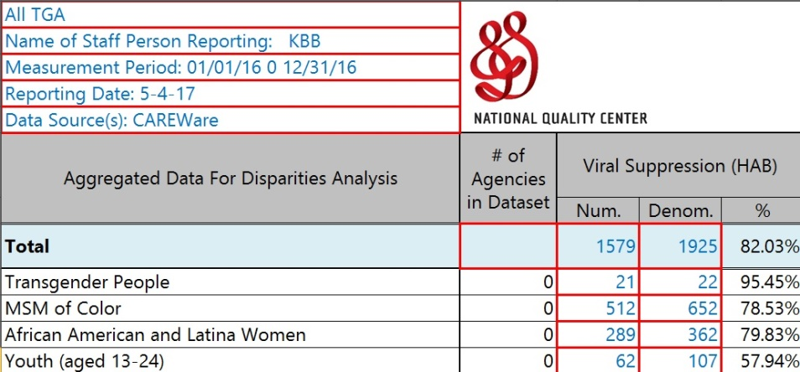

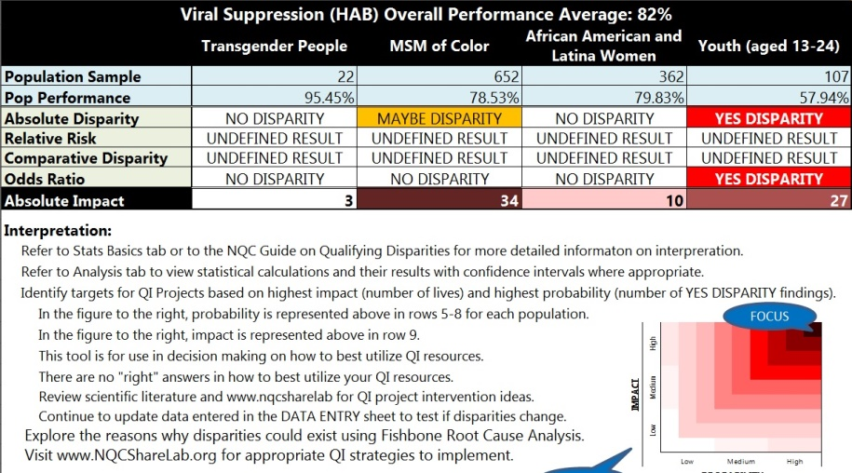

2:05 - AIM Statement Overview and Small Group Activity - Kate Burnett-Bruckman
- Kate reviewed summaries from the current VLS projects in place and directed attendees to the three page worksheet found in their folders. Because this is a living document she encouraged all CQM members to look over their summary and please e-mail her if any updates are requested.
- Kate also reviewed with the group that while current QI projects are required among the funded providers, community agencies and advocates are also encouraged to develop projects that the Part A office can offer assistance where needed.
- Members were asked to break out into the following groups and share with each other where they were to date with their VLS QI project, any innovative ideas that they have developed, and any barriers encountered.
  - Group 1 = MSM of Color Focus - AHF, ATF, CCF, and Mercy
  - Group 2 = Agency Wide Focus - Far West, May Dugan, DSAS
  - Group 3 = Youth Focus - MetroHealth, University Hospitals, and Nueva Luz

2:35 - Small Group Report Back - Agency Lead
- Each Group reported back to the Committee the details on one intervention or innovative ideal that was discussed and one key item that they thought the other groups could learn from. Common themes included:
  - How support agencies can assist with common messaging in non-traditional/non-clinical settings.
  - The use of technology for client outreach.
  - The use of common language among agencies when it comes to medical adherence messaging.

3:05 - Training on QI Tools - Clemens M. Steinböck, NQC
- The following workflow map processes were reviewed with the committee:
  - Flowcharts - help you understand processes
  - Run Charts - help you understand the variation in your data
  - Histograms - also help you understand the variation in your data
  - Cause and Effect Diagrams - help you gather and display theories about causes and problems.
- Once sample was reviewed for a VLS project that one of our agencies might be faced with.
- Sample tools and a longer tutorial can be found through the National Quality Center’s Quality Academy website.

3:35- Training on Change Management and Dealing with Resistance - Clemens M. Steinböck
- Clemens reviewed a case study on Austrian scientist Ignaz Philipp Semmelweis
- The theory of the diffusion curve and tipping point were discussed to bridge the conversation of how you get your team of coworkers to invest in your quality project.
- The following types in innovators were defined: Innovators, Early Adaptors, Early Majority, Late Majority, and Laggards.
- Clemens reviewed types of resistance and the personality characteristics that you may encounter in your group. For each type of personality, the group discussed the best way to motivate and engage the individual.
- Clemens reviewed the characteristics/skills needed to be a change agent.
- The NQC Quality Academy also has further details of Dealing with resistance and Change Management and can be found at: http://nationalqualitycenter.org/nqc-activities/qualityacademy/quality-academy-links/

4:05 - CQMC Reporting Form - Kate Burnett-Bruckman
- Kate reviewed with the group the new Quarterly QI report form. All funded providers will be submitting this report quarterly for specific date frames outlined on the report. Reports must be completed in Word and submitted to Zach Levar. All community and non-funded agencies and committee members are also encouraged to look over the form and determine if they would like to implement their own QI projects and share the data with the group.
- The electronic report form will be e-mailed out to all members along with a copy of the instructions for pulling data out of CAREWare.

4:10 - Next Steps and Wrap Up - Melissa Rodrigo
- Kate to send out an electronic version of the reporting form and instructions on pulling the data from CAREWare the group.
- All funded agencies must submit their first CQM report by Friday, June 2, 2017 to Zach at zlevar@ccbh.net.
- Zach will send out an e-mail asking agencies to write up the language they currently use in text messages so that the group can discuss common messaging and language at the next meeting.
- Meeting dates for all of 2017-2018 have been confirmed. Please mark your calendars with the following:
  - September 25, 2017 - 1:00pm - Cuyahoga County Board of Health
  - December 18, 2017 - 1:00pm - Cuyahoga County Board of Health
  - March 19, 2018 - 1:00pm - Cuyahoga County Board of Health
  - June 18, 2018 - 1:00pm - Cuyahoga County Board of Health
  - September 17, 2018 - 1:00pm - Cuyahoga County Board of Health
  - December 17, 2018 - 1:00pm - Cuyahoga County Board of Health
- The next CQMC meeting will be held at 1:00 pm on Monday, September 15, 2017 here at the Cuyahoga County Board of Health.

